**Day 26 Task: Jenkins Declarative Pipeline:**

One of the most important parts of your DevOps and CICD journey is a Declarative Pipeline Syntax of Jenkins.

**Some terms:**

* **What is Pipeline -** A pipeline is a collection of steps or jobs interlinked in a sequence.
* **Declarative:** Declarative is a more recent and advanced implementation of a pipeline as a code.
* **Scripted:** Scripted was the first and most traditional implementation of the pipeline as a code in Jenkins. It was designed as a general-purpose DSL (Domain Specific Language) built with Groovy.

# Why you should have a Pipeline:

The definition of a Jenkins Pipeline is written into a text file (called a [Jenkinsfile](https://www.jenkins.io/doc/book/pipeline/jenkinsfile" \t "_blank)) which in turn can be committed to a project’s source control repository.  
This is the foundation of "Pipeline-as-code"; treating the CD pipeline as a part of the application to be versioned and reviewed like any other code.

Creating a Jenkinsfile and committing it to source control provides a number of immediate benefits:

Automatically creates a Pipeline build process for all branches and pull requests.

Code review/iteration on the Pipeline (along with the remaining source code).

# Pipeline syntax:

pipeline {

agent any

stages {

stage('Build') {

steps {

//

}

}

stage('Test') {

steps {

//

}

}

stage('Deploy') {

steps {

//

}

}

}

}

# Task:

# Create a New Job, this time select Pipeline instead of Freestyle Project.

# Complete the example using the Declarative pipeline.

* Start jenkins server and click on “New Item” on home screen.

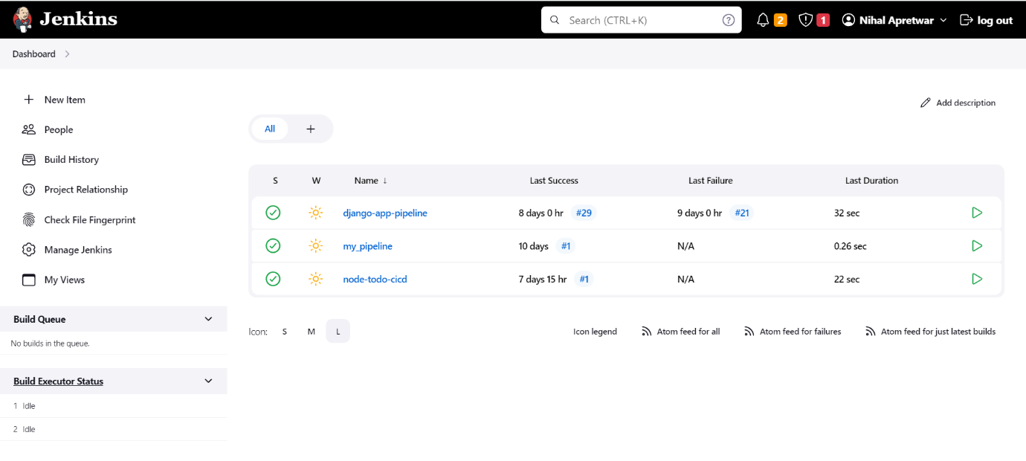

* Enter the desired name and after entering name, select **Pipeline** and click on ok button.

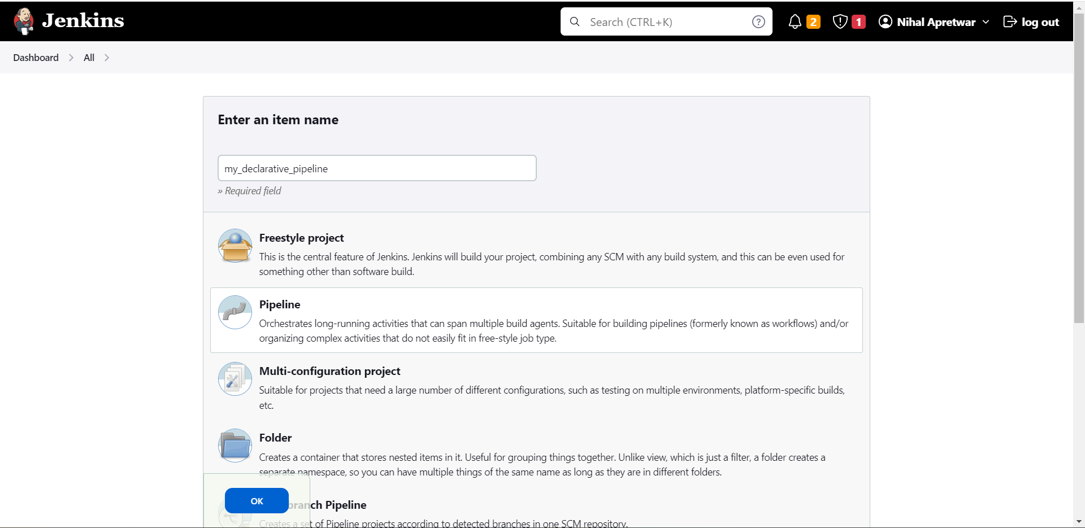

* Go to project configuration page and give the desired description for the job.

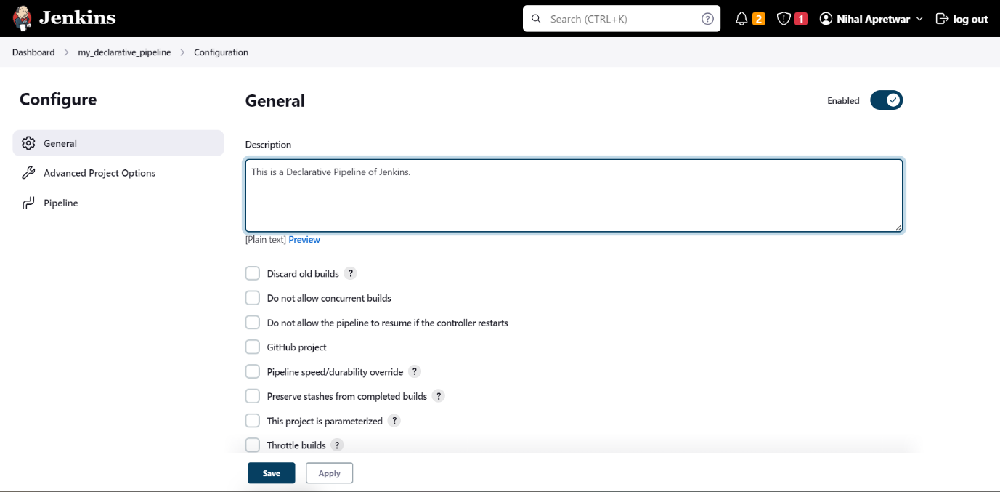

* Now go to the pipeline session, in definition select Pipeline script

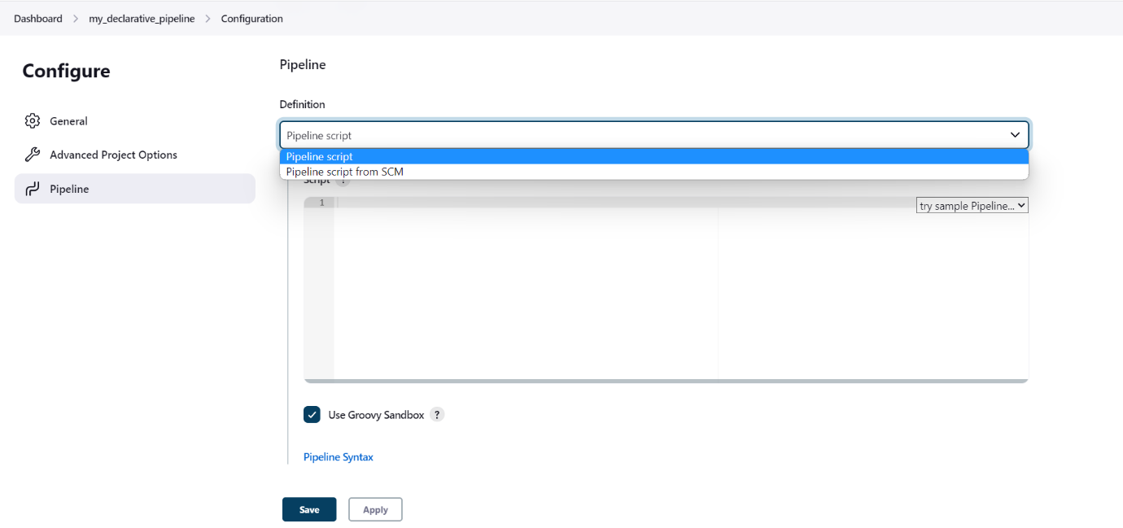

* Start typing the code for building a declarative pipeline and click on the save button.

**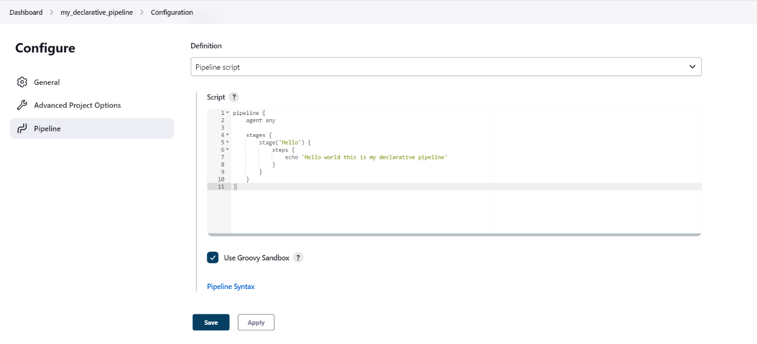**

* Now build the project.

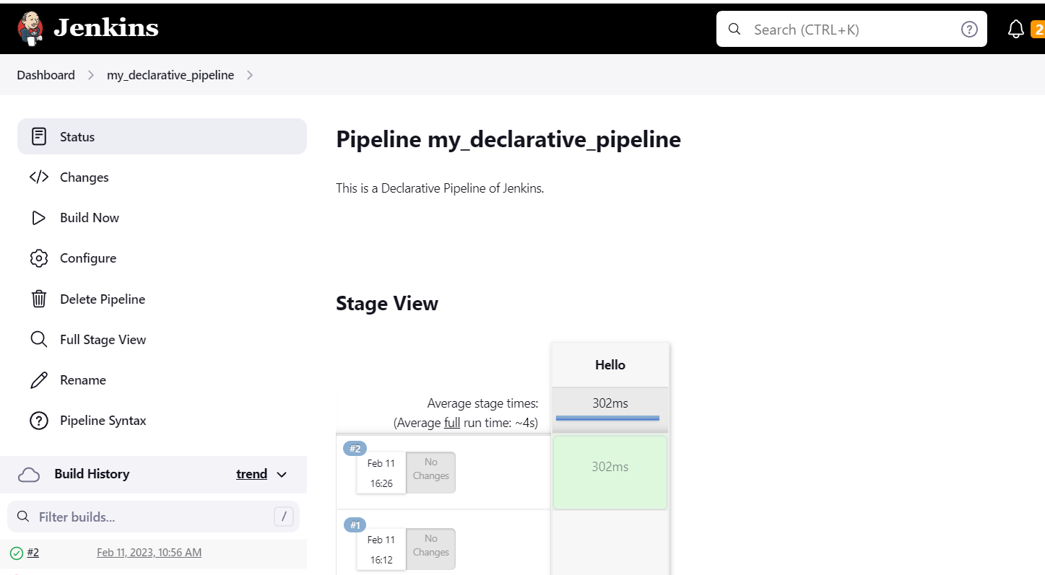

* Now you see the job will be build successfully.

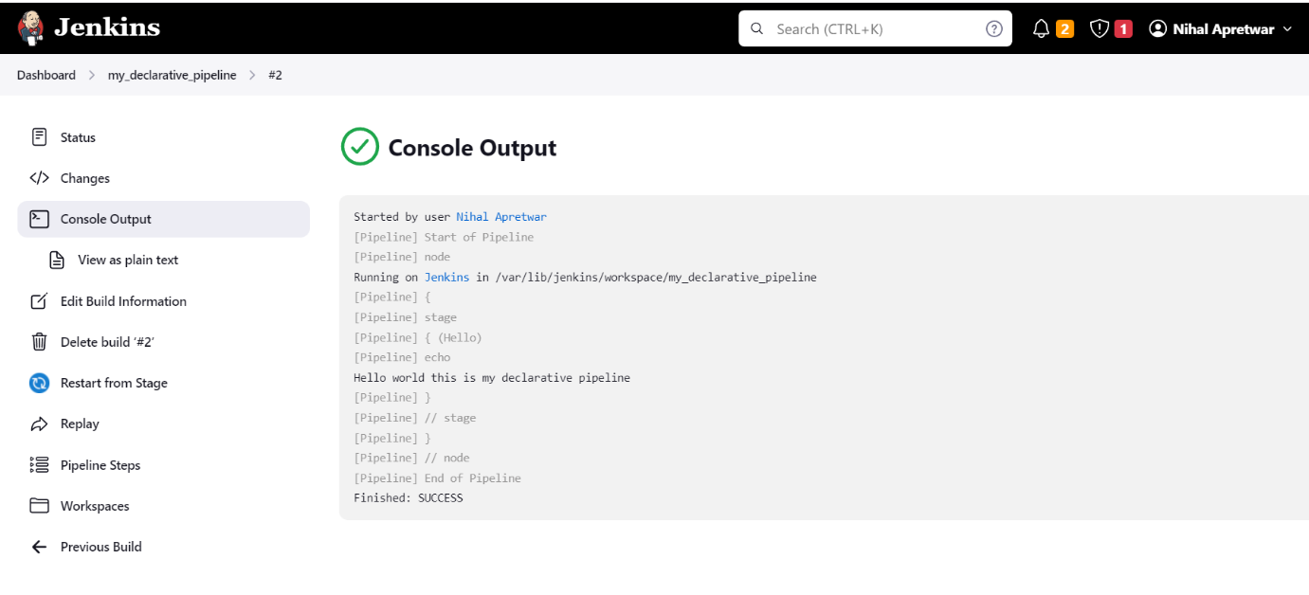

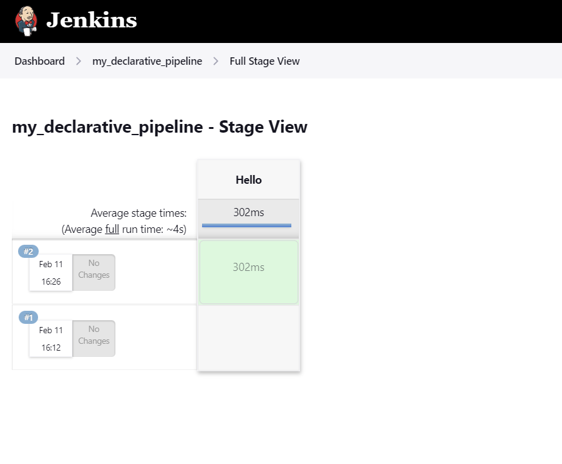

# Thank you for reading!

# Happy Learning 😊